Git Tools
To explore the robust functionality of Git, we need some tools. Git comes with some of its tools like Git Bash, Git GUI to provide the interface between machine and user. It supports inbuilt as well as third-party tools.
Git comes with built-in GUI tools like git bash, git-gui, and gitk for committing and browsing. It also supports several third-party tools for users looking for platform-specific experience.

Git Package Tools
Git provides powerful functionality to explore it. We need many tools such as commands, command line, Git GUI. Let's understand some essential package tools.

Git Bash
Git Bash is an application for the Windows environment. It is used as Git command line for windows. Git Bash provides an emulation layer for a Git command-line experience. Bash is an abbreviation of Bourne Again Shell. Git package installer contains Bash, bash utilities, and Git on a Windows operating system.
Bash is a standard default shell on Linux and macOS. A shell is a terminal application which is used to create an interface with an operating system through commands.
By default, Git Windows package contains the Git Bash tool. We can access it by right-click on a folder in Windows Explorer.

Git Bash Commands
Git Bash comes with some additional commands that are stored in the /usr/bin directory of the Git Bash emulation. Git Bash can provide a robust shell experience on Windows. Git Bash comes with some essential shell commands like Ssh, scp, cat, find.
Git Bash also includes the full set of Git core commands like git clone, git commit, git checkout, git push, and more.

Git GUI
Git GUI is a powerful alternative to Git BASH. It offers a graphical version of the Git command line function, as well as comprehensive visual diff tools. We can access it by simply right click on a folder or location in windows explorer. Also, we can access it through the command line by typing below command.
- $ git gui
A pop-up window will open as Git gui tool. The Git GUI's interface looks like as:
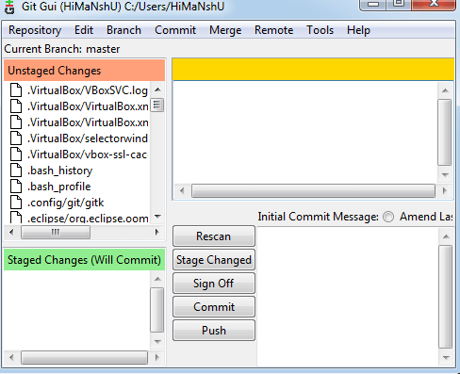
Git facilitates with some built-in GUI tools for committing (git-gui) and browsing (gitk), but there are many third-party tools for users looking for platform-specific experience.

Gitk
gitk is a graphical history viewer tool. It's a robust GUI shell over git log and git grep. This tool is used to find something that happened in the past or visualize your project's history.
Gitk can invoke from the command-line. Just change directory into a Git repository, and type:
- $ gitk [git log options]
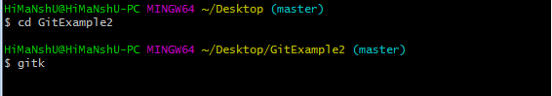
This command invokes the gitk graphical interface and displays the project history. The Gitk interface looks like this:
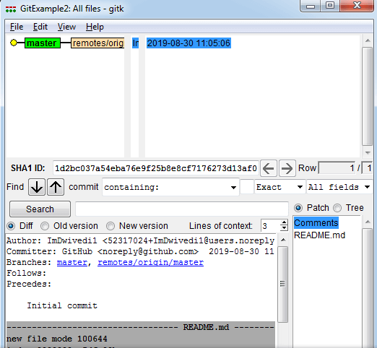
Gitk supports several command-line options, most of which are passed through to the underlying git log action.

Git Third-Party Tools
Many third-party tools are available in the market to enhance the functionality of Git and provide an improved user interface. These tools are available for distinct platforms like Windows, Mac, Linux, Android, iOS.
A list of popular third party Git tools are as follows:
Tools | Platforms |  |  |  |  | Price | License Type
 | Windows | Mac | Linux | Android | iOS
SourceTree | Yes | Yes | No | No | No | Free | Proprietary
GitHub Desktop | Yes | Yes | No | No | No | Free | MIT
TortoiseGit | Yes | No | No | No | No | Free | GNU GPL
Git Extensions | Yes | Yes | Yes | No | No | Free | GNU GPL
GitKraken | Yes | Yes | Yes | No | No | Free/$29/$49 | Proprietary
SmartGit | Yes | Yes | Yes | No | No | $79/user/free for non-commercial use | Proprietary
Tower | Yes | Yes | No | No | No | $79/user (30 days free trial) | Proprietary
Git Up | No | Yes | No | No | No | Free | GNU GPL
GitEye | Yes | Yes | Yes | No | No | Free | Proprietary
gitg | Yes | No | Yes | No | No | Free | GNUGPL
Git2Go | No | No | No | No | Yes | Free with in-app purchases | Proprietary
GitDrive | No | No | No | No | Yes | Free with in-app purchases | Proprietary
GitFinder | No | Yes | No | No | No | $24.95 | Proprietary
SnailGit | No | Yes | No | No | No | &9.99/Lite version | Proprietary
Pocket Git | No | No | No | Yes | No | 1.99€ | Proprietary
Sublime Merge | Yes | Yes | Yes | No | No | $99/user, $75 annual business sub, free eval | Proprietary

